
PAF-Karachi Institute of Economics & Technology
College of Computing and Information Sciences
Course Project Proposal Form

Sno. | Stud. ID | Names | Course Name
1 | 9363 | Muhammad Ali | INTERNET & INTRANET ARCHITECTURE
2 | 9501 | Shaikh Huzaifa Ahmed | INTERNET & INTRANET ARCHITECTURE
3 | 8105 | Taqi Haider

Project Title:
ALI MOTORS NETWORKING SYSTEM

Table of Contents

Contents
Introduction 4
Network Diagram 4
Figure 0.0 4
Functional Features 5
Main Routers 7
Redistribution 7
Introduction 7
Figure 0.1 8
Backup Route 10
Karachi Cluster 13
Network Diagram 13
figure 0.2 13
Open Shortest Path First (OSPF) 14
Introduction 14
ACL 15
Introduction 15
Figure 0.3 15
Figure 0.4 15
Figure 0.5 15
Figure 0.6 15
Natting 16
Introduction 16
Dynamic network address translation 17
Figure 0.7 17
Figure 0.8 20
Figure 0.9 20
Figure 0.10 20
Port Security 24
Introduction 24
Cluster Quetta 25
Rip V2 26
Introduction 26
Figure 0.11 27
Figure 0.12 27
Cluster Lahoor 31
EIGRP 31
Introduction 31
Features 32
Network Diagram 32
Figure 0.14 32
Cluster Islamabad 34
Static 35
Introduction 35
Uses 36
Advantages 37
Disadvantages 37
Figure 0.16 39
Conclusion 41

Introduction

Description of the Project:
We have designed a networking model for ALI MOTORS because they are manufacturing different cars according to user requirements and to communicate with each branch they need a network to secure the company data,Send Email, communicate with data server etc. They have different branches Karachi, Lahore, Islamabad and Quetta .These four branches are interconnected with each each other with different protocols. Each branch has its Email server ,Database server ,Web server and DNS server .These Four branches are connected with main Head Office ALI Motors if the ALI MOTORS router is down the Backup link/router is on up state. All the protocols which are used in the model are redistributed.

Network Diagram:

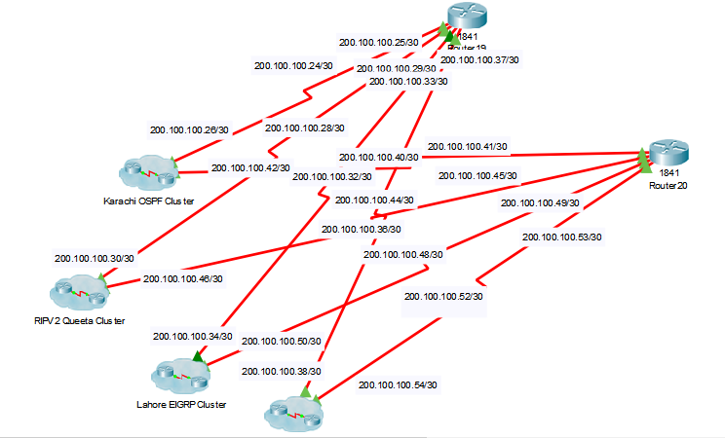
Fig 0.0

Functional Features

The Protocols that are used in the network:

RIP Version 2

OSPF

EIGRP

Routing Techniques:
- Static routing

Security Mechanism:
- Port security
- ACL

Address Translation
- NAT

Redistribution:

The use of a routing protocol to advertise routes that are learned by some other means, such as by another routing protocol, static routes, or directly connected routes, is called redistribution.

Servers:
- Web server
- Email server
- DNS server
- Database Server

Router and Switch Detail:

15 routers are used, 3 use in static routing, 4 routers use in RIP version 2, 4 routers use in EIGRP and 4 routers use in OSPF
2 Switches use in OSPF, 2Switches in EIGRP, 1in RIP and 1 in STATIC ROUTER

IP Address:

Public IP:
50.0.0.1/25---55.0.0.255/25
150.0.0.1/25---155.0.0.255/25
200.100.100.0/25---205.100.100.255/25

Private IP:
10.0.0.0/24--- 10.3.0.0/24
172.16.0.0/24---172.19.0.0/24
192.168.0.0/24---192.168.10.0/24

Hardware and Software Requirements

Cisco Packet Tracer

Main Routers:

There are two main router named router 19 and router 20, router 19 use for backup link. We have to do redistribution in it for performing the operations.

Redistribution

Introduction
Using a routing protocol to advertise routes that are learned by some other means, such as by another routing protocol, static routes, or directly connected routes, is called redistribution. While running a single routing protocol throughout your entire IP internetwork is desirable, multi-protocol routing is common for a number of reasons, such as company mergers, multiple departments managed by multiple network administrators, and multi-vendor environments. Running different routing protocols is often part of a network design. In any case, having a multiple protocol environment makes redistribution a necessity.
Differences in routing protocol characteristics, such as metrics, administrative distance, classful and classless capabilities can effect redistribution. Consideration must be given to these differences for redistribution to succeed.
EIGRP & IGRP need five metrics when redistributing other protocols: bandwidth, delay, reliability, load, and MTU, respectively.

Metric | Value
Bandwidth | In units of kilobits per second; 10000 for Ethernet
Delay | In units of tens of microseconds; for Ethernet it is100 x 10 microseconds = 1 ms
Reliability | 255 for 100 percent reliability
Load | Effective load on the link expressed as a number from 0 to 255 (255 is 100 percent loading)
MTU | Minimum MTU of the path; usually equals that for the Ethernet interface, which is 1500 bytes

Fig 0.1

Show running:

Router eigrp:

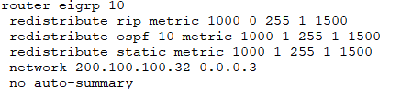

Router ospf:

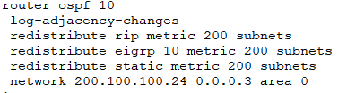

Router rip:

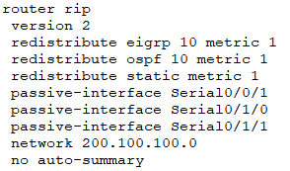

Router static:

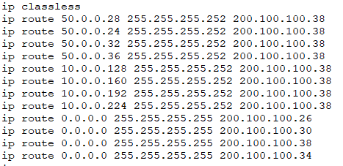

Backup Route:

"For protocols that don't have their own routing information tables, such as IGRP, the first method is used. Every time IGRP receives an update about a route, it attempts to install the updated information in the routing table. If there's already a route to this same destination in the routing table, the installation attempt fails.

For protocols that have their own database of routing information, such as EIGRP, IS-IS, OSPF, BGP, and RIP, a backup route is registered when the initial attempt to install the route fails. If the route installed in the routing table fails for some reason, the routing tabel maintenance process calls each routing protocol process that has registered a backup route, and asks them to reinstall the route in the routing table. If there are multiple protocols with registered backup routes, the preferred route is chosen based on administrative distance."

Above paragraph, What is the meaning of ' registered backup route' .

When Two routers have multiple protocols(RIP and OSPF), there are OSPF route on routing table which is chosen by AD value.

Then, Rip has the routes on its database as a registered backup route?

If Not so, what is the problem?

As my testing result, I didn't find routes registered on rip database by 'show ip rip database'.

If 'show ip rip database' command cannot show the whole database of rip, then ho can I indicate that the route registered to rip database as a 'registered backup route'

Show running

Router ospf:

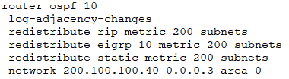

Router Rip:
Show running

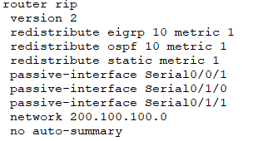

Router static:
Show running

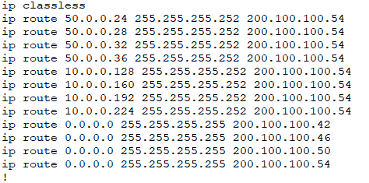

Router eigrp:
Show running

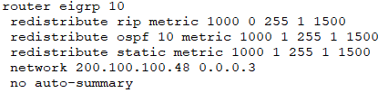

Karachi Cluster

Network Diagram:

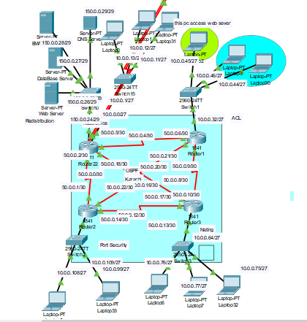

Fig 0.2

In this cluster we configure OSPF routing protocol and the laptop 2 which connected to router 1 can only access web server because of ACL you can see it in fig.__ and more details about ospf and acl given blow.
If we want to access pcs of router 2 from router for that we do ping on router 3 and get reply from pcs of router 2. But the reply would not come from private network. Because of NATTING. More information about natting is given blow.

Open Shortest Path First (OSPF)

Introduction:
Open Shortest Path First (OSPF) is a dynamic routing protocol for use in Internet Protocol (IP) networks. Specifically, it is a link-state routing protocol and falls into the group of interior gateway protocols, operating within a single autonomous system (AS).
OSPF is used to determine the best route for delivering the packets within an IP networks.

Enabling the OSPF Routing Protocol
The following command is needed in order to enable OSPF routing protocol on the router:

Router(config)#router ospf process-number

The process-number is nothing more than a number local to the router. It’s only used to distinguish processes within a router and can be given an arbitrary value. This value does not have to be the same on every router within the area. However, it is always good practice to keep this number the same for better administration.

Access Control List (ACL):

Introduction
Access Control List (ACL) are filters that enable you to control which routing updates or packets are permitted or denied in or out of a network. They are specifically used by network administrators to filter traffic and to provide extra security for the network. This can be applied to routers (Cisco).

Show Running

access-list 145 permit tcp host 10.0.0.45 host 150.0.0.27 eq www
access-list 145 deny tcp any host 150.0.0.27 eq www
access-list 145 permit ip any any

You can see here we are only allowing 150.0.0.27 to access web page other then all will deny the request to access web page.

Deny Webserver:

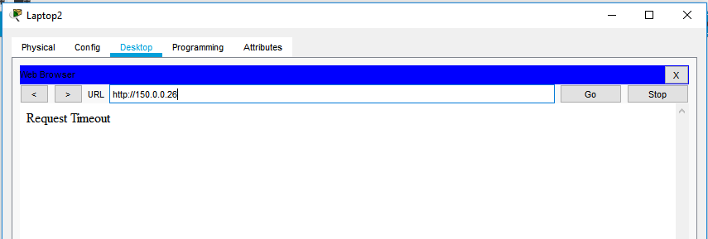
Fig 0.3

Allow Email Server:

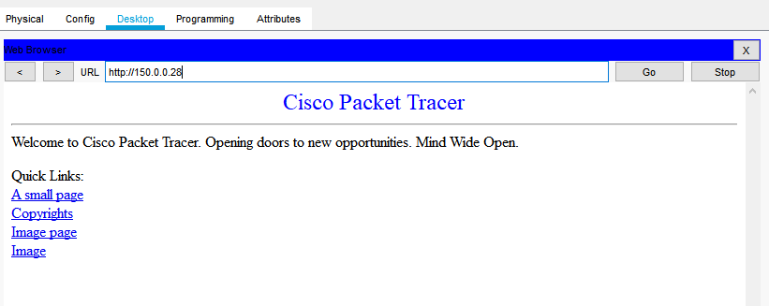
Fig 0.4

Allow DNS Server:

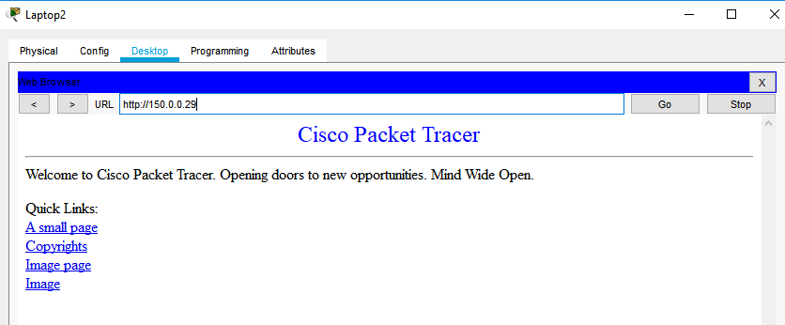
Fig 0.5

Allow Database Server:

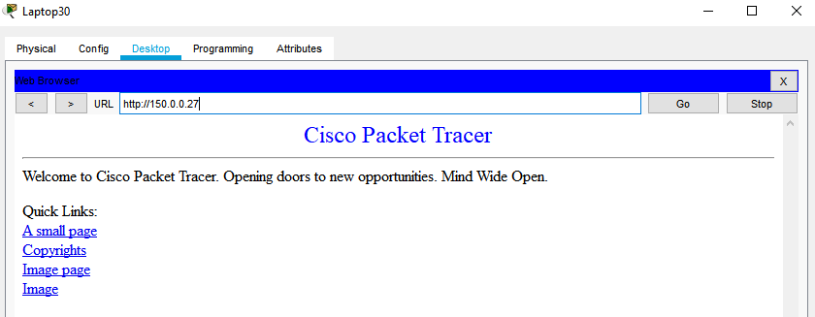

Fig 0.6

Router 1
We also configured Nating on router 1 introduction and details about Natting is given blow.

Natting:

Introduction:

Network address translation (NAT) is a method of remapping one IP address space into another by modifying network address information in the IP header of packets while they are in transit across a traffic routing device.[1] The technique was originally used as a shortcut to avoid the need to readdress every host when a network was moved. It has become a popular and essential tool in conserving global address space in the face of IPv4 address exhaustion. One Internet-routable IP address of a NAT gateway can be used for an entire private network.
IP masquerading is a technique that hides an entire IP address space, usually consisting of private IP addresses, behind a single IP address in another, usually public address space. The hidden addresses are changed into a single (public) IP address as the source address of the outgoing IP packets so they appear as originating not from the hidden host but from the routing device itself. Because of the popularity of this technique to conserve IPv4 address space, the term NAT has become virtually synonymous with IP masquerading.
As network address translation modifies the IP address information in packets, NAT implementations may vary in their specific behavior in various addressing cases and their effect on network traffic. The specifics of NAT behavior are not commonly documented by vendors of equipment containing NAT implementations

Dynamic network address translation
Dynamic NAT, just like static NAT, is not common in smaller networks but is found within larger corporations with complex networks. The way dynamic NAT differs from static NAT is that where static NAT provides a one-to-one internal to public static IP address mapping, dynamic NAT usually uses a group of available public IP addresses.

Check Natting:

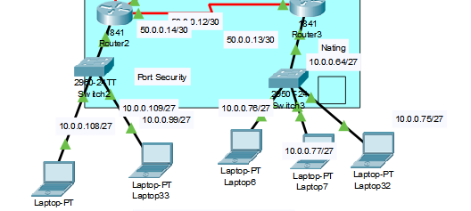
Fig 0.7

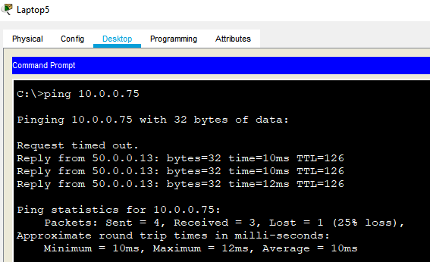
Fig 0.8

In fig___ you can see we ping a private ip but get reply from a public ip. This can only be possible by using natting in topology.

Reply of nating from Lhore egrp cluster:

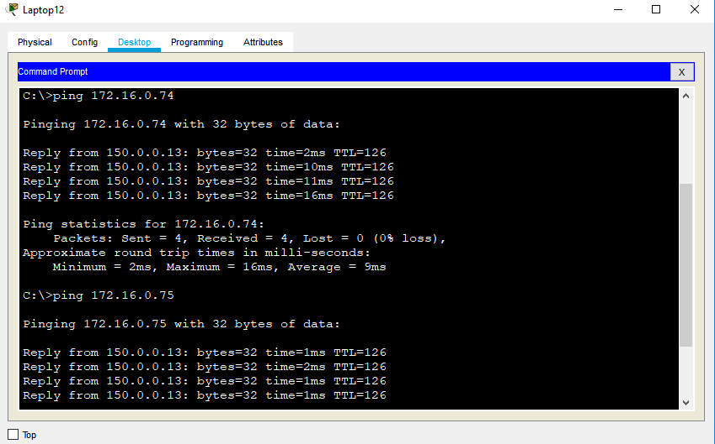
Fig 0.9

Nating reply ospf to karachi:

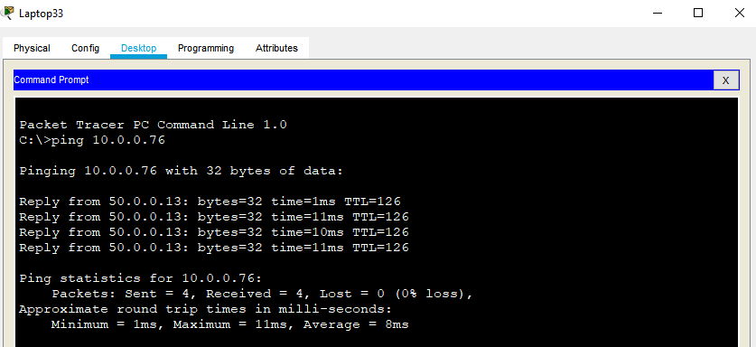

Fig 0.10

show ip interface brief

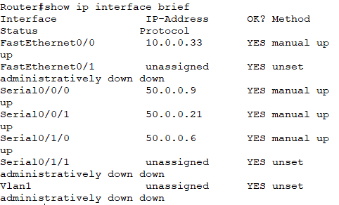

Running Configuration

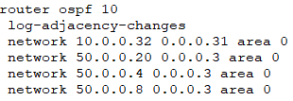

For router 22:

Running Configuration

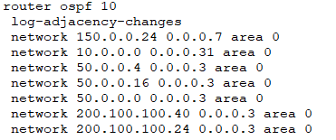

show ip interface brief

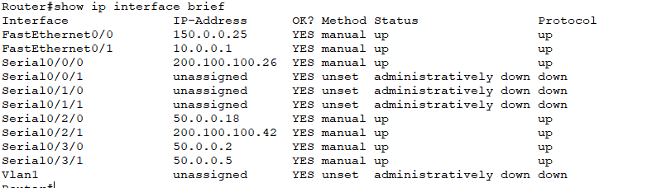

For router 2:
show ip interface brief

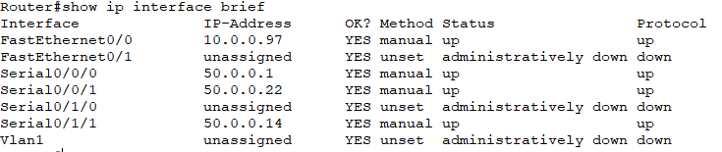

Show running:

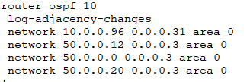

Port security:

Introduction
You can use port security with dynamically learned and static MAC addresses to restrict a port’s ingress traffic by limiting the MAC addresses that are allowed to send traffic into the port. When you assign secure MAC addresses to a secure port, the port does not forward ingress traffic that has source addresses outside the group of defined addresses. If you limit the number of secure MAC addresses to one and assign a single secure MAC address, the device attached to that port has the full bandwidth of the port.

- You can statically configure all secure MAC addresses by using the switchport port-security mac-address mac_address interface configuration command.
- You can allow the port to dynamically configure secure MAC addresses with the MAC addresses of connected devices.
- You can statically configure a number of addresses and allow the rest to be dynamically configured.
- If the port has a link-down condition, all dynamically learned addresses are removed.

Show port-security

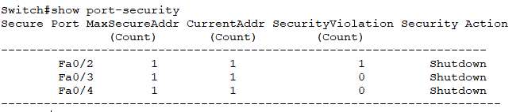

For router 3:

show ip interface brief

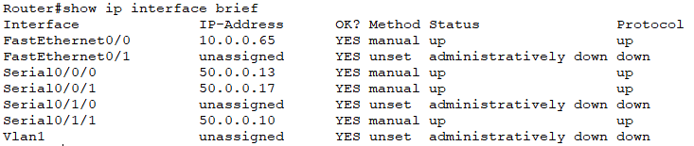

Show running:

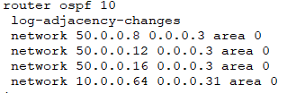

Cluster Quetta:

Rip V2

Introduction
- Classless Routing Protocols

- The true characteristic of a classless routing protocol is the ability to carry subnet masks in their route advertisements.

- Classless Routing Protocol, sent over UDP port 520

- Includes the subnet mask in the routing updates.

- Automatic summarization at major network boundaries can be disabled.

- Updates sent as multicasts unless the neighbor command is uses which Sends them as unicasts.

Configuring static Routes

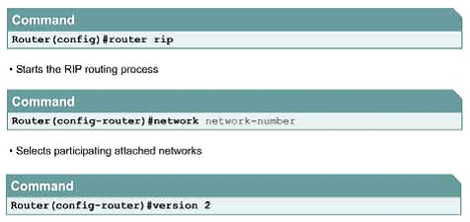
Fig 0.11

Network Diagram:

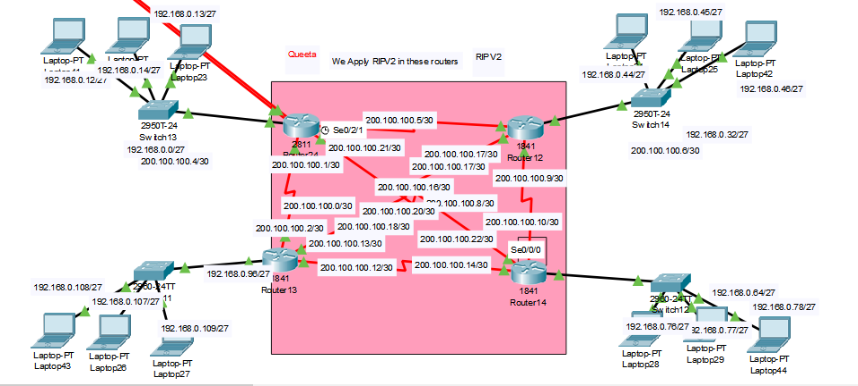

Fig 0.12

Router 24:

show ip interface brief

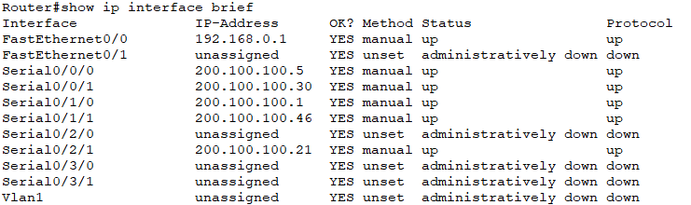

Show running

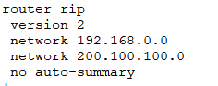

Router 12:

show ip interface brief

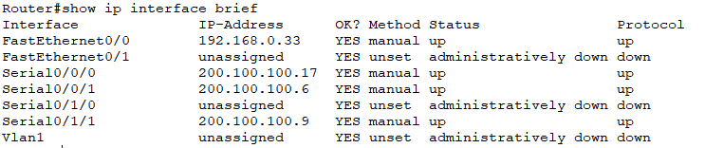

Show running

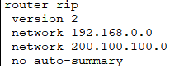

Router 14:

show ip interface brief

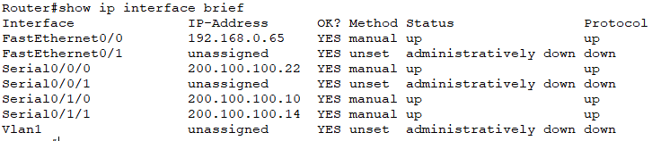

Show running

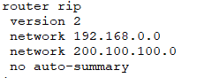

Router 13:

show ip interface brief

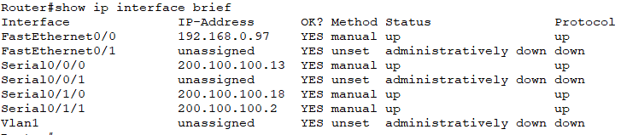

Show running

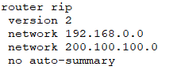

Cluster Lahore

Enhanced Interior Gateway Routing Protocol (EIGRP)

Introduction:
Enhanced Interior Gateway Routing Protocol (EIGRP) is an advanced distance-vector routing protocol that is used on a computer network for automating routing decisions and configuration. The protocol was designed by Cisco Systems as a proprietary protocol, available only on Cisco routers. Functionality of EIGRP was converted to an open standard in 2013 and was published with informational status as RFC 7868 in 2016.

EIGRP is used on a router to share routes with other routers within the same autonomous system. Unlike other well-known routing protocols, such as RIP, EIGRP only sends incremental updates, reducing the workload on the router and the amount of data that needs to be transmitted.

EIGRP replaced the Interior Gateway Routing Protocol (IGRP) in 1993. One of the major reasons for this was the change to classless IPv4 addresses in the Internet Protocol, which IGRP could not support.

Features:

EIGRP supports the following features

- Support for Classless Inter-Domain Routing (CIDR) and variable length subnet masking. Routes are not summarized at the classful network boundary unless auto summary is enabled.
- Support for load balancing on parallel links between sites.
- The ability to use different authentication passwords at different times.
- MD5 and SHA-2 authentication between two routers.
- Sends topology changes, rather than sending the entire routing table when a route is changed.
- Periodically checks if a route is available, and propagates routing changes to neighboring routers if any changes have occurred.
- Runs separate routing processes for Internet Protocol (IP), IPv6, IPX and AppleTalk, through the use of protocol-dependent modules (PDMs).
- Backwards compatibility with the IGRP routing protocols

Network Diagram:

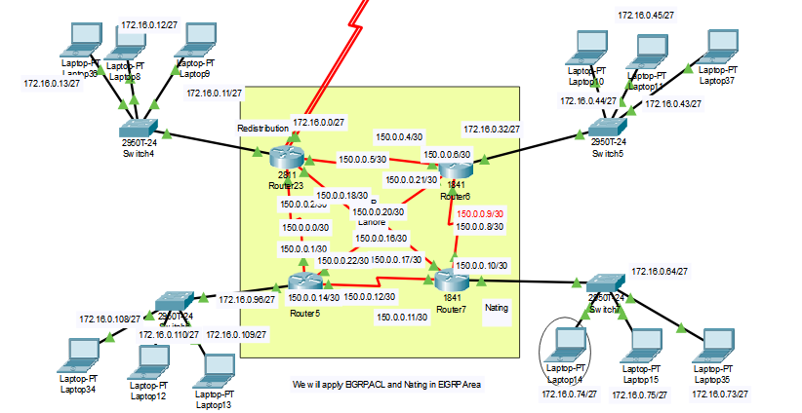

Fig 0.14

Router 23:

show ip interface brief

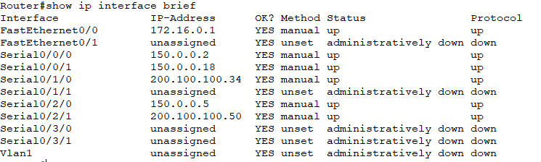

Show running

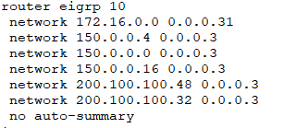

Router 6:
show ip interface brief

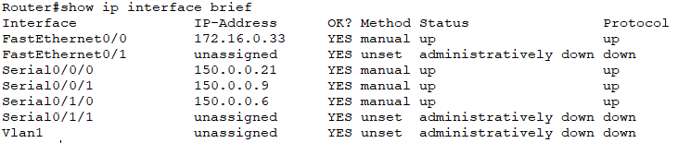

Show running

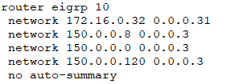

Router 5:
show ip interface brief

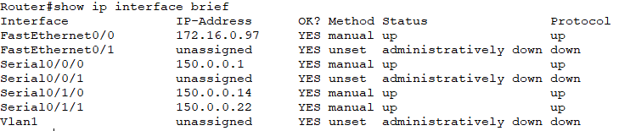

Show running

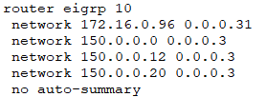

Router 7:
show ip interface brief

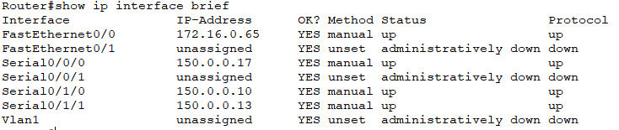

Show running

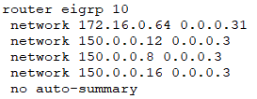

Cluster Islamabad

Static:

Introduction:
Static routing is a form of routing that occurs when a router uses a manually-configured routing entry, rather than information from a dynamic routing traffic. In many cases, static routes are manually configured by a network administrator by adding in entries into a routing table, though this may not always be the case. Unlike dynamic routing, static routes are fixed and do not change if the network is changed or reconfigured. Static routing and dynamic routing are not mutually exclusive. Both dynamic routing and static routing are usually used on a router to maximize routing efficiency and to provide backups in the event that dynamic routing information fails to be exchanged. Static routing can also be used in stub networks, or to provide a gateway of last resort.

Uses:
Static routing may have the following uses:

Static routing can be used to define an exit point from a router when no other routes are available or necessary. This is called a default route.
Static routing can be used for small networks that require only one or two routes. This is often more efficient since a link is not being wasted by exchanging dynamic routing information.
Static routing is often used as a complement to dynamic routing to provide a failsafe backup in the event that a dynamic route is unavailable.
Static routing is often used to help transfer routing information from one routing protocol to another (routing redistribution).

Advantages:
Static routing, if used without dynamic routing, has the following advantages

- Static routing causes very little load on the CPU of the router, and produces no traffic to other routers.
- Static routing leaves the network administrator with full control over the routing behavior of the network.
- Static Routing Is very easy to configure on small networks.

Disadvantages:
Static routing can have some potential disadvantages,

Human error: In many cases, static routes are manually configured. This increases the potential for input mistakes. Administrators can make mistakes and mistype in network information, or configure incorrect routing paths by mistake.

Fault tolerance: Static routing is not fault tolerant. This means that when there is a change in the network or a failure occurs between two statically defined devices, traffic will not be re-routed. As a result, the network is unusable until the failure is repaired or the static route is manually reconfigured by an administrator.

Administrative distance: Static routes typically take precedence over routes configured with a dynamic routing protocol. This means that static routes may prevent routing protocols from working as intended. A solution is to manually modify the administrative distance.

Administrative overhead: Static routes must be configured on each router in the network(s). This configuration can take a long time if there are many routers. It also means that reconfiguration can be slow and inefficient. Dynamic routing on the other hand automatically propagates routing changes, reducing the need for manual reconfiguration.

Network Diagram:

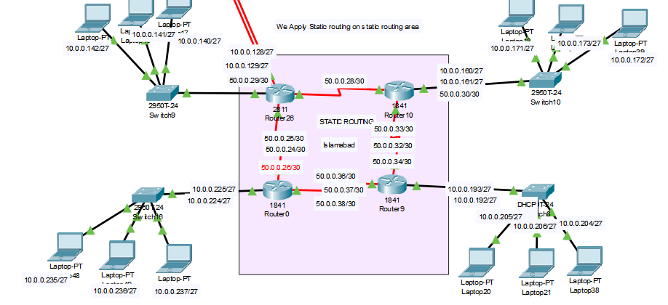
Fig 0.16

Router 26:

show ip interface brief

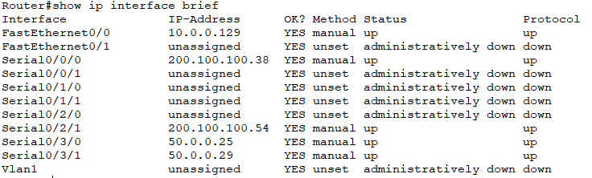

Show running

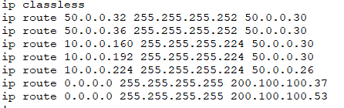

Router 10:

show ip interface brief

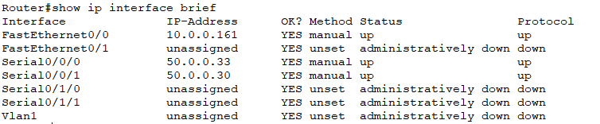

Show running

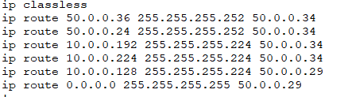

Router 0:
show ip interface brief

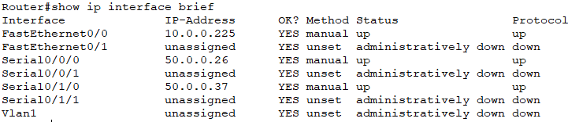

Show running

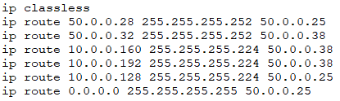

Router 9:
show ip interface brief

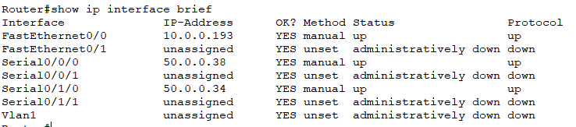

Show running

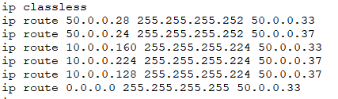

Conclusion:

These all protocols are in working condition. This project also secures because of Access control list security and natting. We also do port security in order to secure our ports. All ips given to hosts are dynamic.

You can also get project from this link:

https://github.com/huxe/routing_project

